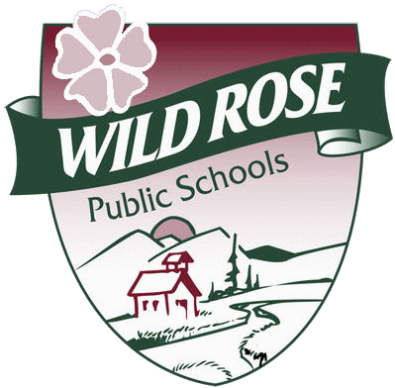 | Wild Rose Public Schools  Consent to Participate in Group Work  Wild Rose School Division Family Wellness Program

I/We, _____________________________________** hereby consent
parent(s)/guardian

For _______________________ to participate in a group program called
Child

______________________________________________________, as
Name of Program

offered through the Wild Rose School Division Family Wellness

I/We understand that our child will participate in this group with his or her peers who are also experiencing difficulties of a similar nature. Although the importance confidentiality amongst participants will be expected, the nature of group work does not guarantee this.

I/We am/are aware that there are certain limitations to confidentiality, and that they include:

- Disclosure to prevent harm to self or others,
- Suspicion of child abuse and/or neglect
- Federal Provincial Law (FOIP or subpoena)
- Disclosure of a violent crime and/or the intent to commit a violent crime,
- The disclosure is in the best interest of the child.

In addition, I also provide consent for the Family Wellness Worker to consult with other professionals in the school district regarding myself, my child and/or my families’ situation on a need-to-know basis and only when in the best interest of myself, my child and/or my family. I understand that I may put limitations on this contact and will do so in writing and deliver it to the Family Wellness Worker.

Consent is valid from August to August, unless revoked in writing by the undersigned.

parent(s)/guardian |  | Date
parent(s)/guardian |  | Date

** The person signing this form and consenting to this service must be the legal guardian of the child, as defined in the Family Law Act. In most cases, this will be the parent of the child, but the FWW will take reasonable steps to determine who the guardian(s) of the child is/are.

