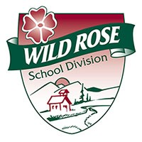
Wild Rose School Division

Parent Consent for:

Level B Assessment

Date of referral (yy/mm/dd):

Student Information:

Child’s Legal Name:

Date of Birth (yy/mm/dd): Grade:

Student’s Address:

Parent/Guardian: Home phone #:

Business phone #: Extension:

I understand it is my responsibility to advise the school in writing of my withdrawal of any portion of, or all of this written consent.

Name of consenting person (please print) Relationship to child

Signature of consenting person Date

Name of consenting person (please print) Relationship to child

Signature of consenting person Date

School Information - if you have any questions or require clarification please contact:

School Contact:

Phone: Fax: Email:

To be able to provide educational support services to your child, we need to ask you for some personal information.

Pursuant to the School Act, the Student Record Regulation and the Freedom on Information and Protection of Privacy Act, the School
Jurisdiction may disclose to other professionals involved in your child’s program, relevant information in your child’s Cumulative Record.

