## Sample Parent Letter for Targeted Services

**Pencil Grasp and Printing Skills**

Dear Parents,

We are excited to announce that we will be running a program with a group students to target skill development in the areas of printing and pencil control. The group will be run as a partnership between the school and an Occupational Therapist from Children’s Rehabilitation Services.

The goal of the program is to help students improve their:

* Pencil grasp and Control
* One of the most efficient ways to hold a pencil is with a tripod grasp. This means that the thumb and index finger are pinching the pencil (making an “O”), while the shaft of the pencil is resting on the side of the middle finger, towards the tip.
* Printing
* The readability of writing can improve if the organization of writing is improved. This includes becoming more awareness of where letters sit on a line, how letters and words are spaced and the size of letters.

Sessions will focus on improving pencil control, spacing of words and letters, letter sizing and line placement. If you have any questions about the program, please feel free to talk to your classroom teacher.

Teacher Name

School Name

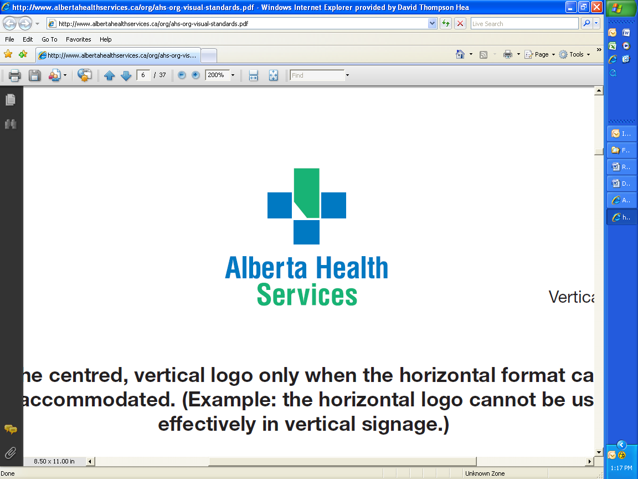 

**Get Ready to Read!**

Dear Parents,

Over the next few months, Speech-Language Pathology staff from Alberta Health Services will be partnering with your child’s teacher to teach important literacy skills in your child’s classroom.

The **Get Ready to Read** program consists of 8 separate lessons and includes fun learning experiences for your child in the classroom. The following topics will be discussed:

1. Rhyming
2. Syllable Segmentation
3. Blending and Segmenting Sounds
4. Deleting and Changing Sounds in Words
5. Short Vowels
6. Long Vowels: introducing magic ”E”
7. Vowel Digraphs
8. R-Controlled Vowels

After each topic is introduced in the classroom, you will receive follow-up ideas for encouraging these literacy skills at home. With your involvement, your child can learn even more from this valuable program.

We are excited about working together to teach important literacy skills!

Sincerely,

______________________ _______________________

Teacher NameSpeech-Language Pathologist

School Name

________________________

Speech-Language Pathologist Assistant

 

**Get a Grip on Pencil Grasp**

Dear Parents,

We are excited to announce that we will be running the Get a Grip on Pencil Grasp program in the classroom. The program will be run as a partnership between the school and an Occupational Therapist from Children’s Rehabilitation Services. The program is based in the classroom and will involve eight 30 minute sessions.

The goal of the program is to help students improve their pencil grasp and pencil control. One of the most efficient ways to hold a pencil is with a tripod grasp. This means that the thumb and index finger are pinching the pencil (making an “O”), while the shaft of the pencil is resting on the side of the middle finger, towards the tip. The group activities will be geared toward developing a tripod grasp.

Sessions will focus on improving the foundational skills necessary for efficient pencil grasp such as hand strength and manual dexterity. An efficient pencil grasp is a key skill that allows children to print neatly and quickly without getting tired or sore. Pencil grasps can be very difficult to change past Kindergarten, which is why it is important to work on these skills early.

It will begin the week of November 15th, 2013 and run for approximately 8 weeks. If you have any questions about the program, please feel free to talk to your classroom teacher or call ***<INSERT OT NAME>*** at **<*INSERT OT PHONE NUMBER****>.*

**_______________ _______________**

Therapist Name Teacher Name

Occupational Therapist School Name

Children’s Rehabilitation Services

 



**Detective Dan Vocabulary**

Dear Parents,

Isn’t it amazing what a good vocabulary can do for a person? A better vocabulary can support a person in almost any area of life!

This is why we are teaming up with our school’s Speech-Language Pathologist (SLP) at to introduce a way to help support your child’s use and understanding of vocabulary!

We are using an interactive learning program designed to speed up vocabulary development and thinking. Throughout the program, children will be learning new skills for organizing and understanding words with the help of Detective Dan. Detective Dan’s strategies will be used to help students better understand to following parts of vocabulary:

* Description
* Function
* Associations
* Categories
* Similarities and Differences
* Multiple meanings

After each lesson, some information and ideas that can be used at home will be sent home with your child. If family and school are both using these learning strategies, your children will develop even faster ☺

As children learn to use their thinking skills to understand and recall new words, they become more curious. Would you like to find out more about this program? We would love to hear from you. Feel free to contact me if you have any questions.



*Did you know there can be a 30 million word difference in children’s spoken word vocabulary by the time they enter school? Did you know that oral language skills predict reading skill development?*

_________________

Teacher Name

School Name