SSF Meeting - October 1, 2015
Present: Katherine Evans, Liane Huson, Geoff Barnes, Daniel Ceresna, Diane Sell, Bhavna Rao, Catherine Meehan, Rita Steele, Kim Simo, Alana Baxter, Julianna L’Henaff, Wendy Weis, Leah Odynski, Jennifer McClean, Kathy Murch

1. Mindful Meditation - Kristen Spangenberg
-handout given

2. Alberta Health Services Collaborative ProcessesPresentation https://goo.gl/OJZgZV

3. CA RCSD Website http://carcsd.ca/
4. Printing IPPs - Darryl Denys & IPP Process
Discussion:
- School address, phone number are not populate directly at this time (SSFs are having to input). We have notified Clevr of this concern
- Student signature option should be selectable not permanent
- If Goals are not printing on Full IPP option - make sure the field (current level of performance) is filled in
- Change from IPP coordinator → Student Support Facilitator
- We need to be able to add additional Short Term Goal (ADD) with no limit
- Teachers will have access to all of the IPP program except the FORMS Links & printing Links
- A drop down menu for to input staff names with autocomplete will be added (in a couple of weeks)
- We are unable to have a Strategies bank at this time. This will be something that we will build this year
- Individual school logos will be fixed by next Monday so that they will show up on the IPP print out
- Teachers will be automatically be linked to the students as connected by their timetable
- Teachers will all have default password will be clevr123 which they will then need to change
- Teacher author comment → we will tackle this by having classroom teacher who is needed for the IPP in the comments section or make it very clear in the actual goal
Wild Rose IPP Protocols
- SSFs will be required to contact teachers that are not completing their IPPs in a timely fashion to remind them but if this is not successful then School Administrators will be invited to follow up (principal)
- We will no longer be offering an Accommodated IPP without a remediation goal for students in ECS to grade 9. However, an accommodated IPP will still be an acceptable practice for students in grade 10, 11, 12
- These IPPs will be called Uncoded IPP in the program
- We will be writing Monthly summaries for all students who are coded or on modified programs
- There will be no requirement for a monthly summary for Accommodated IPPs (IPPs that generally only have one remediation goal).

Problems with Clevr
-Make a Google Document (Leah Odynski) Action Taken Column about problems with clevR

RTI Conference (December 3,4,5)
-RTI conference might be optional as school administrators may not be attending
-Kathy Murch will get more clarification

TA PD
-TAs will be required to write PGP plan which will be reviewed by either SSFs or school administers
- $200.00 for each TA in the division (except PUF)
-PUF is handled by Pam Moberg, details to come
-In order to access the $200 from the district, TAs will be required to fill out a PD request form to Kathy Murch. SSFs will be required to approve all PD activities.
-Leah Odynski will be offering TouchChat/Pictello/FVHS session on the October 23rd CAAMSE/ Teacher PD day
-Geoff Barnes has contacted Alberta Health Services to provide some PD on October 23
-Kathy Murch will provide $1000.00 for the north and the south to promote TA PD this year
-Leah will forward the PGP Presentation PowerPoint & PGP Template & TA PD Request form to SSFs. Kathy Murch has already forwarded this package to school administers

CAAMSE PD Days for the 2015/2016 school year are Friday October 23, Monday March 7 & Thursday, June 29

ASIST Training
-Each school in the district needs to have at least 2 people (doesn’t need to be SSF or FFW, could be a TA) trained in ASIST
-Please contact Kathy Murch as soon as possible if you don’t have 2 people in the school who are trained so that she can get a sense of whether or not to provide this training

Zones of Regulation http://www.zonesofregulation.com/
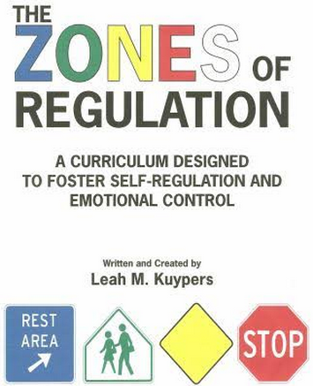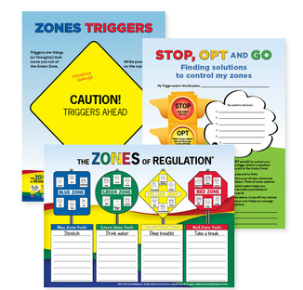
-excellent program
-compilation of several successful social thinking programs
-There is also a great app for both iPad & Android tablets http://goo.gl/KL1sf3
-Lochearn (school wide), DCS & Aurora (school wide) already doing it
-Lochearn & Pioneer have the program materials. Please check with them if you would like more information.
--Blaire Sangster, Bonnie (Enhanced OT/PT & Kari Loetzen (CARC) $1200.00 per day have provided excellent PD presentations on this program
-Sensory regulation can also be tied to the Zone of Regulation program
-Both Daniel & Liane have wonderful presentations that they have provided their staff on the Zones of Regulation that they would share
-Kathy will look into providing this program to the whole District including TAs

RCSD
-Reporting is required twice a year December and May
-SSFs will need to get information to Kathy Murch by December 7, 2015 & May 15
-Reporting forms from last year can be used

Wraps vs. Case Conference
-Wrap Around Meetings are intended for situations when a team approach by many community agencies are involved such as Mental Health, Child and Family Services, RCMP, probation, Westward goals, McMann youth services, AIM for success, etc.
-If you need only one discipline (Mental Health), feel free to you can handle it as a case conference and therefore, District Office does not need to be involved
-Please feel free to contact Kathy to discuss individual cases or if you are unsure which approach would be appropriate

November 4th SSF meeting is cancelled

Next SSF February 26th in DCS or Evergreen
Wendy Weis and Julianna L’Henaff will look into providing an meeting room for our next meeting

Upcoming Dates for SSFs
October 16-17 Celebrating Challenges Conference Edmonton, Alberta
http://www.specialeducation.ab.ca/conferences Fantasyland Hotel, WEM

October 28 -30 The Alberta School Calgary, Alberta
Mental Health Conference The Coast Plaza Hotel
http://www.jackhirose.com/workshop/alberta-mental-health-conference/

February 26 District Wide SSF Meeting Drayton Valley, Alberta
Location To Be Determined

June 10 District Wide SSF Meeting Raven Meadows Golf Course

