Student Services
Manual

WILD ROSE SCHOOL DIVISION

Wild Rose School Division: http://www.wrsd.ca/

Student Services Weebly: http://studentserviceswrsd.weebly.com/

Table of Contents

Section 1: Wild Rose School Division

- Mandate, Mission, Vision, Beliefs

2. Student Services Operating Principles
- Beliefs
- Policy Guidelines

Section 2: Roles and Responsibilities

School Based Personnel

- Parents
- School Based Personnel
- Principal
- Lead Team
- Classroom Teacher
- Student Support Facilitator
- Family Wellness Worker
- Educational Assistant

Division Based Personnel

- Director of Student Services
- Director of Wellness
- Student Services Coordinator
- Assistive Technology Facilitator

Section 3: Services and Supports

Collaborative Response Model: Jigsaw Learning

- Step One: Collaborative Team Meetings
- Step Two: Informing the Collaborative Team Meetings, Assessments
- Step Three: Pyramid of Interventions: What will we do about it?

Section 4: Referral and Intervention Processes

Glossary

SECTION 1 Wild Rose School Division

Mandate:
To improve the life chances of ALL students.

Mission:

To create powerful learning environments that inspire excellence in learning and support the wellbeing of all students.

Vision:
All students complete their programs with a sense of dignity, purpose and hope.
Beliefs:
- Education must be a hopeful activity
- All students can be passionate, successful learners
- Our primary purpose is facilitating student development in the academic, social and personal realms
- The Teacher at the front of the class is a powerful model and the most influential variable in student learning
- Learning best occurs in a positive, safe and supportive environment that enhances wellbeing, resilience and a respect for diversity
- Positive relationships are at the foundation of good learning
- Learning best occurs in positive, safe and supportive environments
- Students will respond positively to high expectations
- Student learning should be active, interactive and appropriate to the individual
- Technology must be used appropriately and innovatively to enhance learning
- Students must be prepared for life in a rapidly changing civil democratic society
- The school system must function seamlessly as part of the larger social fabric

Student Services Operating Principles

Beliefs
- A quality inclusive education system promotes an inclusive model of education and creates expectations that every student has equal opportunity to have equitable access to curricular outcomes and learning environments.
- All students have the capacity to learn.
- All children have the right to a supportive learning environment where individual differences and learning needs are respected and accommodated.
- The independence of each student is developed to maximum potential.
- Parents are partners in their children’s education.
- Active learning requires appropriate curriculum and diversity of instructional methods, materials and assessment practices.
- The classroom teacher has a central role in the development and implementation of each child’s program supported through collaborative processes that is based upon current pedagogy and best practice.
- Our inclusionary education practice is based on the belief that:
  - Programming and services will be provided in the most appropriate and least restrictive environment.
  - A continuum of services and a variety of settings will be necessary to address the diversity of individual needs.
  - All programming will strive to promote inclusion within the school community and the community at large.

Policy Guidelines
Instructional programming is under the direct supervision of the Principal.

This manual aligns with the following:
a. Alberta Education Guidelines and Policies
b. Wild Rose School Division Manual of Administrative Policies

SECTION 2 Roles and Responsibilities

Parents
Parents are crucial partners in the collaborative school-based team since they are their child's first teacher. All parents need to be informed of their child‘s progress at school and involved in making decisions that affect their child‘s education. School and division personnel are required to ensure that parents have the information needed to make informed decisions. Although they are not involved in direct implementation within the school setting, parents participate in planning, implementing, and evaluating programs and supports by:

- Advocating for their child
- Providing for their child‘s basic needs
- Ensuring that their child attends school
- Identifying their child‘s needs and communicating these to the teacher
- Supporting and encouraging their child‘s learning at home and at school
- Providing information that augments the teacher‘s observations of the child in the school setting
- Providing input at the planning and monitoring meetings regarding their child‘s progress
- Following through on Individual Program Plan goals in home and community settings
- Participating in assessing the effectiveness of strategies to promote development, particularly in areas related to personal independence; self-control and behavior management; communication; and skills
- Partnering with school teams in accessing community based programming
- Communicating with the school regarding their concerns, observations, and celebrations on a regular basis

School-Based Personnel
School based personnel includes the Administrator(s), classroom Teacher(s), Student Support Facilitator(s), Family Wellness Worker, and Educational Assistant(s). Although the roles of the Principal/Vice Principal and classroom Teacher are much broader, they have primary responsibility for meeting the needs of all students within their respective schools and classrooms.

Principal
Section 20 of the The School Act, stipulates that the school Principal should be responsible for instructional leadership in the school and is responsible for programming for all students within the school. The School Leader Standard is described by the following competencies and indicators:

A School Leader:
- Fosters positive working relationships within the school community
- Collaborates with the school community to create and implement the school’s shared vision, mission, values and goals
- Nurtures and sustains a school culture that values and supports learning
- Ensures that every student has access to quality and optimum learning experiences
- Effectively directs school operations and manages resources

Roles and Responsibilities

- Promotes and supports an inclusive model of education and creates expectations that every student has equal opportunity to participate in and benefit from the programs and activities of the school
- Advocates for all students and demonstrates an appreciation for diversity
- Provides leadership in creating and maintaining a collaborative culture in which staff work together to solve problems and promote learning among all students and personnel
- Establishes effective practices for meeting diverse learning needs within a system that provides equitable access to learning outcomes
- Ensures accountability of all teachers to adapt to meet the learning needs of all students
- Works with staff to establish, implement, review and revise school-based processes for:
- Authentic parent engagement in planning for programs and services to meet their child‘s needs
- Identification of annual needs for inclusive support services within the school
- Planning and implementation of a service delivery model that is consistent with school division policy and appropriate to the needs within the school
- Development, implementation, and review of Individual Program Plans
- Provides direct supervision of Teaching staff and Educational Assistants
- Provides leadership in planning for the professional development needs of staff, monitoring the application of newly acquired knowledge and skills, and evaluating effectiveness in enhancing student learning
- Develops the opportunity and provides leadership in the formation of a school-based team and ensures such is maintained
- Ensures that regular Program Planning Team Meetings are scheduled within their school with the attendance of teachers, FWW, SSF and relevant staff

Lead Team
- It is recommended that administrators develop a Lead Team to promote and support school improvement and student achievement that aligns with Wild Rose School Division’s vision and provincial goals
- Members of the Lead Team could include: Principal, Vice Principal, Student Support Facilitator and Family Wellness Worker and Teacher Representative. This team should meet on a regular basis (weekly/bi-weekly)

Classroom Teacher
Sections 18(1) and (2) of the The School Act and the Alberta Education Current Teaching Quality Standards section stipulates the duties of teachers within the school system as the following:

- A Teacher establishes, promotes and sustains inclusive learning environments
where diversity is embraced and every student feels welcome, safe, cared for,
and respected, by:
- Promoting equality and acceptance with respect to ethnicity, culture, religious belief, gender, gender identity, gender expression, physical ability, cognitive ability, family status and sexual orientation;
- Implementing appropriate universal, targeted and/or specialized strategies to address students’ strengths, learning challenges and areas for growth;
- Being aware of and responding to students’ emotional and mental health needs;
- Employing classroom management strategies that:
- optimize learning for every student;
- Result in a positive, safe environment that is conducive to student learning;
- Involve students in establishing classroom routines; recognizing and responding to students’ learning needs with supports, including assistive technologies where required, to enable and/or improve learning;
- Recognizing and responding to students’ learning needs with supports, including assistive technologies where required, to enable and/or improve learning;
- Incorporating students’ personal and cultural strengths into teaching and learning; and
- Providing opportunities for student leadership.

Classroom Teachers are the primary educator for all students in the classroom and take a lead role in the development, implementation, and assessment of programming for all students.
Where the student's program involves specialized instruction by someone other than the classroom Teacher, collaboration among the learning team is necessary to ensure that specialist recommendations are implemented.

Roles and Responsibilities

- Reviewing student cumulative records, in either June or September, and other pertinent student records, with particular emphasis on identifying exceptional needs and strategies that have been successfully used in the past
- Providing direct instruction for all students within the classroom
- Maintaining current records of student progress and achievement
- Providing initial classroom-based assessment and developing knowledge of individual student needs, abilities, and interests
- Identifying students who are experiencing difficulties and those who excel
- Communicating with parents on a regular basis regarding their child‘s progress, program, and any exceptional needs (e.g., Parent/Teacher interviews, written reports/report cards, Team meetings)
- Accessing supports from the Student Support Facilitator
- In collaboration with the Student Support Facilitator and with the consent of parents, referring students for further assessment and/or services as needed
- Developing, implementing and assessing student’s Individual Program Plans (IPP) in consultation with Student Support Facilitator and stakeholders
- Updating formative assessments of the IPP goals on Monthly Summaries
- Assigning specific classroom duties for the Educational Assistant that support student programming
- Providing leadership, guidelines, and evaluative feedback to the Educational Assistant within the classroom
- Collaborating with other learning team members

Student Support Facilitator
Student Support Facilitators are Teachers who are knowledgeable about inclusive education and are skilled at facilitating collaboration and sharing best practices. The Student Support Facilitator supports the equity and access to quality programming and resources for all students. The Student Support Facilitator works with learning teams to provide students with the opportunity to access learning environments that are the least restrictive and most inclusive.

- Resource Provider: Providing information and resources upon teacher request. Routinely providing updates on new resources.
- Instructional Leader: Building Teacher capacity to explore the use of research-based instructional strategies (e.g., differentiated instruction, positive behaviour supports, universal design for learning, response to intervention) and innovative practices to ensure that all students have access to meaningful and effective learning opportunities.
- Classroom Supporter: Building Teacher capacity to explore and enhance innovative instructional practices through systematic modeling, co-teaching and feedback.
- Learning Supporter: In collaboration with staff, identifying school needs to implement professional learning plans that enhance Teachers’ abilities to address the unique strengths and needs of all learners in the school community.
- Mentor: Building and maintaining relationships with Teachers so that a high level of trust is created and maintained between the Teacher and the Student Support Facilitator.
- School Leader: Working closely with colleagues and Administrators to promote and support school improvement that aligns with Wild Rose School Division’s vision and provincial goals.
- Assessment Guide: Helping Teachers select, understand and use data to improve instruction.
- Change Agent: Promoting exploration and change in instructional practices (e.g., introducing innovative ideas, questioning practices, making observations, new technology).
- Lifelong Learner: Modeling, experiencing and promoting continuous learning experiences

The Student Support Facilitator is often designated as the key contact within their school for students with diverse learning needs.

Roles & Responsibilities

- Administer Level B Assessments (Woodcock Johnson IV, KeyMath, etc.) (Level B Assessment Parent Consent form)
- Develop schedules and assigning duties of Educational Assistants in consultation with school administration
- Use a variety of assessment procedures to gather additional information necessary to determine appropriate interventions and programming for students with diverse learning needs. This may include observations, analysis of work samples, interviews, meeting with parents, informal inventories and checklists, and formal assessments as necessary.
- Schedule and facilitate Program Planning Team meetings (PPT) in collaboration with school administration, Family Wellness Workers and Teacher representatives
- Maintain a brief written record of PPT Meetings and student case conferences to support student learning
- Is a member of the school Lead Team
- Support implementation of Assistive Technology by submitting requests and following up forms (Stage A, B, C, AT form) in consultation with Assistive Technology Facilitator
- Submit referrals for CA RCSD consultants (OT, SLP, PT, DHH, Vision, etc.) to secure services (AHS referral form page 1 & AHS referral form page 2)
- Schedule and facilitate monthly CA RCSD Core Team Collaborative Meetings (Elementary & K-12 schools only).
- Ensure that Core Team meeting minutes are documented and accessible to team members
- Initiate and coordinate transition plans for students
- Work with the Family Wellness Worker to provide community supports for students and families with diverse learning needs
- Maintain documents as required by Student Services as outlined by the Director of Student Services
- Collaborate with the student learning teams, in the development of Student Behaviour Support Plans/ Individual Program Plans/Medical Plans
- Collaborate with Family Wellness Worker in the development of the Student Success in Schools Plan
- Collaborate with Learning Teams when developing WrapAround & Violent Threat Risk Assessment referrals
- Attend all Wrap Around & Violent Threat Assessment, and ensure that minutes are recorded for each.
- Support students who access Program Unit Funding that are enrolled in onsite kindergarten programs

Family Wellness Worker
The Family Wellness Program provides short term supportive assistance to students, guardians and their families who are having difficulties and require support at school, home, or in the community. This program is available free of charge to students, guardians, and families with children 0-19 years of age. Family Wellness Workers provide emotional, behavioral, and social supports to individuals and their families. We are a confidential service and access can be made by a referral through parents, guardians, school administrators, teachers, peers, or self referrals.

Roles & Responsibilities

- Provide intervention and/or support services to students and families who may be at risk or currently facing social, emotional, behavioral or family challenges
- Promote effective communication and parenting skills
- Building skills with students individually and in small groups
- Assist in finding information and resources such as counseling, after hours crisis response workers or legal advice
- Advocate within the school or community at large
- Participate in school Lead Team
- Collaborate with community agencies
- Participates in Program Planning Team meetings (PPT) in collaboration with school administration and teacher representatives
- Collaborate and participate in the Wraparound Team meetings & Violent Threat Risk Assessment process

Educational Assistant
While teachers are expected to design programs for students with special needs, Educational Assistants play a key role in many programs for students. Educational Assistants provide physical, emotional, behavioural and academic support in a variety of educational settings in order to maximize the student’s participation in the school environment.
The Golden Rule of Providing Support in Inclusive Classrooms: Support Others as You Would Wish to Be Supported

Roles & Responsibilities

Educational Assistants support all students within a learning environment, even though there will be some times whereby an identified student requires more support.

- Teachers write individual program plans (IPP) for students. It is the Educational Assistant’s role to understand, follow, and to assist in its implementation.
- Educational Assistants may be assigned to support specific students; they are expected, when feasible, to support all students within a learning environment.
- Teachers plan for the provision of personal care assistance for students while it is the Educational Assistant’s role to assist the student with personal care as needed.
- Educational Assistants are responsible for implementing individual emergency evacuation plans as assigned.
- Educational Assistants will not be asked to evaluate students, but may be asked for their input.
- Teachers should discuss how much participation they would like Educational Assistants to have in everyday classroom activities.
- Educational Assistants need to prepare an outline of their daily activities and a timetable for substitutes.
- Educational Assistants will maintain daily or weekly checklists or anecdotal records as assigned.
- Educational Assistants may be assigned supervision duties by school administration. These must be in accordance with the CAAMSE collective agreement.

Division Based Personnel

Director of Student Services
Guided by the Division’s mission statement, vision statement, beliefs, and statement of values the Director of Student Services assists the Deputy Superintendent in fulfilling the general and specific aspects of his role description for the Superintendent as defined in provincial statutes, Alberta Education Policy, Board Policy and Administrative Procedures. The goal of the Director of Student Services is to provide students with medical, social, emotional, physical, or learning disabilities with appropriate educational programming.
Leadership Practices
- Implement, and monitor adherence to legislation, Alberta Education directives including Standards for Special Education (2004), and administrative procedures
- Support and direct school administrators to develop and monitor effective Inclusive Education practices.
- Advise parents, school staff, school administrators, management, and service providers of changes to Inclusive Education policies, procedures, and practices.
- Mediate disputes between parents and school administrators regarding Inclusive Education programs.
- Lead Wrap Around Team Support meetings and Violent Threat Assessment Protocols
- Set and monitor the Student Services budget.
- Approve expenses for the Student Services budget.
- Represent the School Division at Ministerial reviews of Inclusive Learning decisions.

Programming
- In consultation with school staff, review assessment data and assign appropriate Exceptional Needs codes and support for children and students with qualifying disabilities.
- Make recommendations relative to the placement of children/students with diverse learning needs in educational placements outside the division.
- Review programming needs of each school profile and provide support while remaining fiscally responsible to budget constraints.
- In coordination with the Transportation Supervisor, approve special transportation for students who require it.

Coordinate Services
- Establish community partnerships in order to develop and coordinate services and programs for students and their families.
- Establish and maintain an active membership within the Regional Coordination of Service Delivery (CA RCSD) team.
- Attend student case conferences when required.
- Advocate for children and families to access community resources.

Personnel Management
- Provide advice and recommendations regarding the hiring, deploying and supervision of professional staff including Coordinators, Student Support Facilitators and support staff for inclusive education programs.
- Hiring, deploying, and supervising Speech and Language Pathologists, contracting service providers.
- Supervise all aspects of the roles and duties of the Attendance Officer, and act as division representative on Provincial Attendance Board Hearings as necessary and/or required.

Director of Wellness
To truly support students, our schools must be able to address health and wellness. In a healthy school environment educators recognize that wellness is an essential foundation to a school’s core mission of improving life chances for all. Wellness cannot be relegated to an occasional health lesson or physical education class – it is part of math, science, lunch and everything in-between. Schools play a critical role in promoting health and helping students establish lifelong patterns of healthy behavior and strategies. Good health and mental wellness are essential for learning, cognitive development and daily functioning. As a division we also understand that in order to promote wellness in our schools our staff must be well. Healthy, engaged teachers and staff are essential supports for students. The Director of Wellness is responsible for programs and initiatives in Wild Rose School Division directed to address the well-being of our school communities.

Leadership Practices
- Provide leadership, guidance/consultation, clinical supervision, and support to Family Wellness Workers
- Provide consultation and support to School Admin/school staff
- Lead Violent Threat Assessment Protocols and Wrap Around Team Support meetings
- Ensure that accurate, comprehensive and confidential records are kept
- Protocols and procedures – review and update as needed
- Budget (complete financial statements, secure and maintain funding, reports, monthly expenditures projections and tracking, budget statistics, regular feedback to management structure, expenditure of program budget, summer program)
- Ensure program follows mandate as set out in policy/contract
- Maintain/update Family Wellness Worker Weebly; initiate and maintain public awareness of the program
- Leadership and collaboration with leadership team
- Promote and facilitate team building

Programming
- Assessment of student’s and family‘s needs
- Maintain a working knowledge of relevant acts or codes such as: Child, Youth and Family Enhancement Act, Professional Code of Ethics, etc.
- Lead Violent Threat Assessment Protocols and Wrap Around Team Support meetings
- Program evaluation – develop and implement annually or as needed
- Ensure ongoing program development
- Collect and maintain statistics on program trends, issues and outcomes

Personnel Management
- Staffing (interviewing, hiring, growth plans, plans of assistance, orientation of new staff, scheduling, develop job descriptions, etc.)
- Ensure Family Wellness Workers are aware of protocols and procedures and know they are professionally responsible to adhere to them
- Ensure Family Wellness Workers submit proof of active registration with a professional regulatory body (eg. ACSW, AA School Social Worker, etc.)
- Ensure Family Wellness Workers have up-to-date and current training in ASIST and Threat and Risk Assessment Level 1
- Create opportunities for School Social Worker/Family Wellness Worker to build on skills and knowledge

Coordinate Services
- Establish community partnerships in order to develop and coordinate services and programs for students and their families
- Establish and maintain active membership with the CA RCSD team
- Coordinate and attend case conferences/wrap-around meetings when required
- Advocate for children and families to access community resources
- Collaborate with other School Social Worker/Family Wellness Workers throughout Central Alberta
- Ensure Success in School protocols are established and followed for all children in care.

Student Services Coordinator
The purpose of the position of the Student Services Coordinator is to serve as a resource for school-based teams and/or support teachers and liaise with the Student Support Facilitators, Teachers and Educational Assistants.
The resources provided by the Student Services Coordinator may include individualized student support and intervention, on-site assistance in program development and implementation, parent communication, assessment, Individual Program Plan development, Program Planning Team supervision (PPT) and staff inservicing.
The Student Services Coordinator works with Teachers, Educational Assistants, School Psychologists, Speech and Language Pathologists, Occupational Therapists, Physical Therapists, medical community, and other community agencies.
The school team determines the need for additional assistance in solving challenges related to meeting the needs of their students.

Leadership Practices
- Provide direct support to Teachers and in inclusive learning programming
- Working collaboratively to support the development of processes that help to increase staff capacity
- Working with Administrators, Student Support Facilitators and Division Office staff to support their strategic plans in the areas of learning and inclusive learning
- Lead and support creation of collaborative teams to enhance intervention supports
- Share information, best practices and expertise from Alberta Education and the education field with division office lead team, Student Services and school personnel
- Provide professional development within the school division on identified topics and areas of need
- Manage and maintain Clevr program records and provide staff support
- Create and maintain a Student Services weebly with information and resources for staff and families in Wild Rose School Division
Coordinate Services
- Working with a variety of interagency partners such as Regional Collaborative Service Delivery, Alberta Health Services, Child and Family Services and Family Support for Children with Disabilities, and students, staff and families to coordinate and provide programming support for students
- Collaboration with specialists to support student programming
- Coordinate and oversee students who access Program Unit Funding
Program Unit Funding Coordinator (PUF)
Provides the parent, Early Childhood Services (ECS) teacher and/or other instructional personnel with the knowledge, resources and support to meet the learning and developmental needs of ECS children considered eligible for Program Unit Funding (PUF) as a result of an identified severe disability.

Leadership Practices
- Provide parents and staff with information and/or coaching in current methods to facilitate optimal child growth across developmental domains (ie. communication, motor, social, self-help, cognitive and emotional)
- Support parents and Teachers with the early identification of problems and challenges and provide effective problem resolution strategies
- Build and submit the budget to Early Learning Branch/School Finance and reconcile at year end
- Participate in Early Learning Branch meetings and in-servicing

Programming
- Arrange the assessment of the child‘s learning needs for PUF program planning purposes.
- Assist teachers to interpret existing assessment information
- Create, develop, and monitor IPPs for students accessing off site preschool programs.
- Collect student assessments and submit to Early Learning Branch for pre-approval.
- In consultation with the child‘s parents and service providers (i.e. Speech and Language Pathologists, Occupational Therapists, Psychologists, etc.) assisting the ECS Teacher in developing an Individual Program Plan (IPP) for each child
- Assist staff in developing accommodations and adaptations to the ECS program in order to address the child’s educational/development needs as identified in the IPP
- Assist Teachers/Educational Assistants in implementing suggestions provided by specialists.

Coordinate Services
- Assist with the development of a coordinated team approach to PUF program planning
- Identifies and coordinate necessary support services. Provides a liaison function with outside agencies involved in the child‘s program (i.e. physician, Alberta Health Services behavioral support service, Family Supports for Children with Disabilities, etc.)
- Organize service providers (SLP, OT, PT behavior/vision/hearing consultants)
- Organize and collect service contracts

Assistive Technology Coordinator
Assistive Technology Facilitator assists students in performing functions that would otherwise be difficult or impossible to accomplish independently. Assistive technology for learning (ATL) is defined as the devices, media and services used by students with physical, sensory, cognitive, speech, learning or behavioural disabilities to actively engage in learning and to achieve their individual learning goals. The Assistive Technology Facilitator is learner-centered, accessible, collaborative and responsive.

Leadership Practices
- Provide formal and informal training, guidance and assistance to staff, students and family members in using Assistive Technology by providing classroom consultations, workshops, on-site technical assistance, and follow-up support
- Coordinate the purchase, distribution and maintenance of all district Assistive Technology tools (i.e. Laptops, Chromebooks, iPads, iPods, Switches, software, web resource licenses, etc.)
- Collect and maintain statistics on Assistive Technology service delivery trends, issues and outcomes
- Create and maintain a Student Services weebly website with information about Assistive Technology resources available to students and their families in Wild Rose School Division

Programming
- Assist school staff in identifying students who would benefit from using Assistive Technology by using the SETT process (Student, Environment, Tasks, Tools)
- Assist school learning teams in the implementation of no, low, mid and high tech Assistive Technology tools within Wild Rose School Division
- Attend student case conferences, programming planning & transition meetings to support the use of Assistive Technology
- Provide written reports of program recommendations and implementation plans for school learning teams

Coordinate Services
- Collaborate with Alberta Health Rehab Services (SLP, OT & PT) and Low Incidence​ (Vision & DHH) consultants to provide assistive technology tools for students and their families
- Assist families to access community and provincial resources to support students' Assistive Technology needs (I-CAN Centre, ACETS centre, Alberta Aids to Daily Living, etc.)

SECTION 3 Services and Supports

Collaborative Response Model: Jigsaw Learning http://jigsawlearning.ca/

“The Collaborative Response Model is a framework to assist schools and school leaders in the establishment of effective, systemic structures to support the needs of all learners. There are three main components integral to the Collaborative Response Model.” (Kurtis Hewson, Jigsaw Learning)
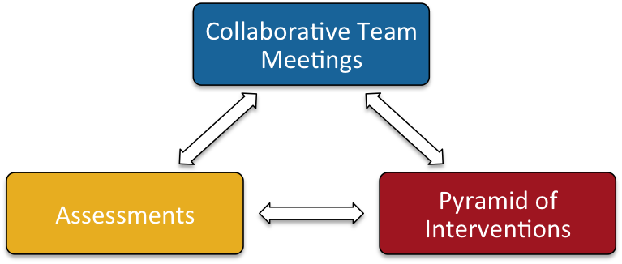
Jigsaw Learning (Retrieved March 2017, https://goo.gl/bI2NhT)

Through the establishment of a Collaborative Response Model, schools and districts can ensure that structures and processes are in place to support inclusive learning environments while informed by research and practices related to:
- Professional Learning Communities
- Collaborative, data informed conversations
- Universal Design for Learning
- Differentiated Instruction
- Formative Assessment

Step One: Collaborative Team Meetings
“Planned and structured opportunities for all staff working with a particular group of students, to meet and discuss student needs and resulting supports. Working as grade level teams, departments, combinations of grades or a team responsible for a pod of students. These meetings are very formalized and place focus on the learning needs of students. It is really important that the discussion and collaboration occurs to capitalize on the strengths of the teaching staff and the collective knowledge that can sometimes go untapped in a school. The Collaborative Team Meetings are the heart and soul of the exemplary Collaborative Response Model.” Kurtis Hewson, Jigsaw Learning; https://goo.gl/bI2NhT)

Step Two: Informing the Collaborative Team Meetings, Assessments
*Assessments answer the question, “Who will we talk about?” (Kurtis Hewson, Retrieved March 2017, https://goo.gl/bI2NhT)
It is essential that you think of the assessments as a way to flag students for conversations. They are not the be-all-and-end-all in determining student success or failure. There are three main classifications of assessment:
- First there are the Benchmarks for all students. These are utilized as a common screener to see which students are having difficulty and work with the teacher assessments that are happening in the classroom to further inform those benchmarks.
- For those students who are flagged as having difficulty or at risk, Diagnostic Assessments help to pinpoint the specific areas that need support.
- Once those specific areas are targeted, Progress Monitoring Assessments are established that are directly aligned with the area being addressed, and happen on a predetermined schedule whether weekly, every other week or monthly to inform us of continued student growth and progress. They also help to inform us if the interventions we are putting in place for students are having an impact.
- It is really important to ensure that the conversations happening at the Collaborative Team Meetings are data informed, utilizing assessments as the conversation starter rather than the final say.

Assessment Planning Template https://goo.gl/Dv9E54
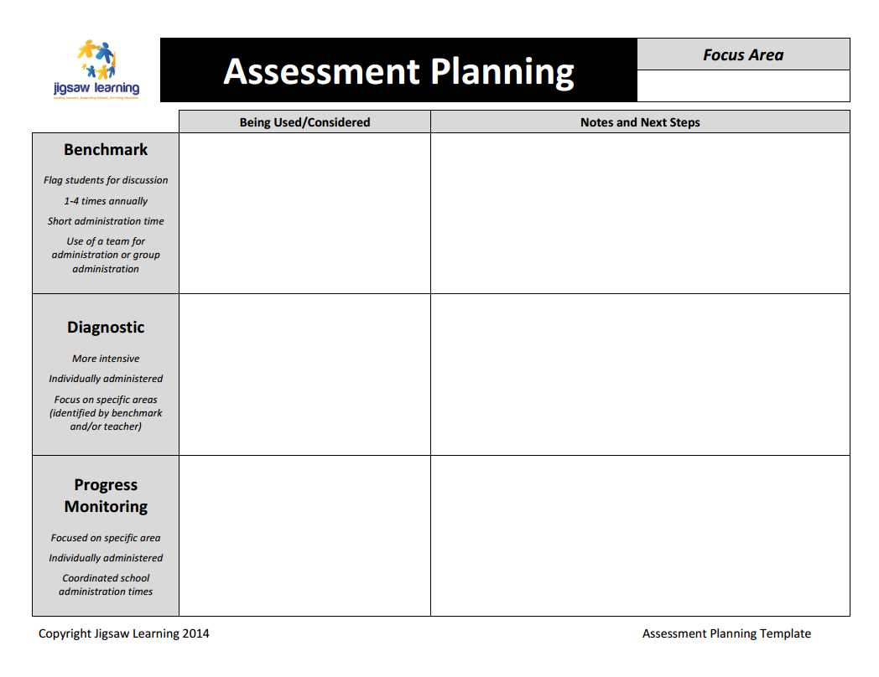

Step Three Pyramid of Interventions: What will we do about it?
Tier 1: Universal Classroom Instruction
Honors and recognizes the essential work of teachers in the classroom
  - Classroom interventions implemented by the teacher
  - Effective instruction for ALL students
  - Program Planning Team meetings:
    - Team collaborates and share differentiated strategies and programming suggestions

Tier 2: School Wide Interventions and Instruction
Collective efforts are made by the school to offer focused and frequent support
  - Program Planning Team meetings:
    - Team collaborates and shares differentiated strategies and programming suggestions

Tier 3: Intensive Interventions and Instruction:
Increased intensity and frequency of support
e. Program Planning Team meetings:
i. Team collaborates and shares differentiated strategies and
programming suggestions
f. Support may be delivered by a para professional
g . Additional time and support
h. Outside resources accessed
i . Individual Program Plan developed

The following examples of intervention strategies are not exhaustive or fully complete. It is expected that each school review the resources and strategies available at their school.
.
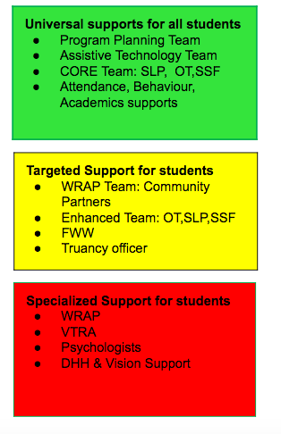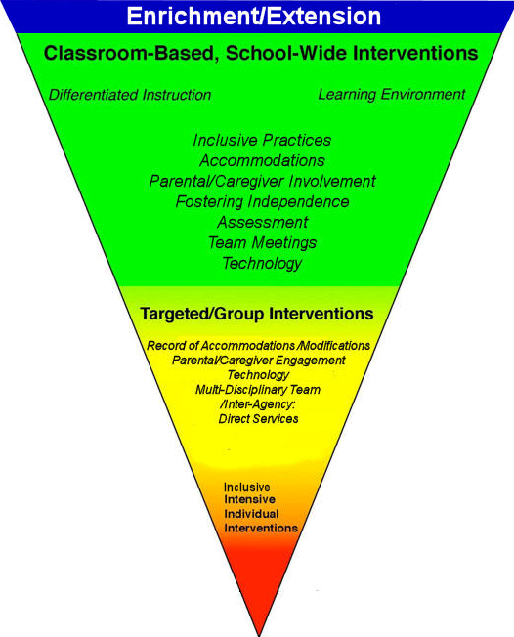
Process Overview
Tier 1: Universal Supports
The first step requires teachers to do essential background work with the student so when they seek additional school level supports the relevant information is collected and initial programming has occurred and parental contact has been made.

School Entry : Upon entering or transitioning to school, information needs to be collected, and could include:

- health and medical factors
- background information related to school
- relevant family information
- school attendance
- cultural background
- learning style
- successful learning strategies

File Review: A comprehensive review of the Student Cumulative File occurs at this time by the classroom teacher and Student Support Facilitator.

Universal/ Inclusive Strategies: The classroom teacher utilizes universal supports and accommodates programming to reflect student needs.

Classroom assessment and documentation: The classroom teacher uses a variety of assessment tools to inform instructional practice and programming, and monitor student progress.

Accommodations: The teacher realizes that the student who is continuing to experience difficulties or is gifted/talented is going to need formalized supports in the classrooms and changes to programming need to be documented on the Individual Program Plan.

Student Support Facilitator: The teacher may seek additional information and advice from other colleagues.

Setting up a Universal Design for Learning
The goal of education is not simply the mastery of content knowledge or use of new technologies. It is the mastery of the learning process. Education should help turn novice learners into expert learners—individuals who want to learn, who know how to learn strategically, and who, in their own highly individual and flexible ways, are well prepared for a lifetime of learning. Universal Design for Learning (UDL) helps educators meet this goal by providing a framework for understanding how to create curricula that meets the needs of all learners from the start.
The UDL Guidelines, an articulation of the UDL framework, can assist anyone who plans lessons/units of study or develops curricula (goals, methods, materials, and assessments) to reduce barriers, as well as optimize levels of challenge and support, to meet the needs of all learners from the start. They can also help educators identify the barriers found in existing curricula. However, to fully understand these Guidelines one must first understand what UDL is.
The UDL Guidelines are organized according to the three main principles of UDL that address representation, expression, and engagement. For each of these areas, specific "Checkpoints" for options are highlighted, followed by examples of practical suggestions. In addition, Examples and Resources to guide implementation as well as a listing of the Research Evidence are offered for every checkpoint. Learn about the changes in UDL Guidelines 2.0
Retrieved from UDL Guidelines http://www.udlcenter.org/aboutudl/udlguidelines
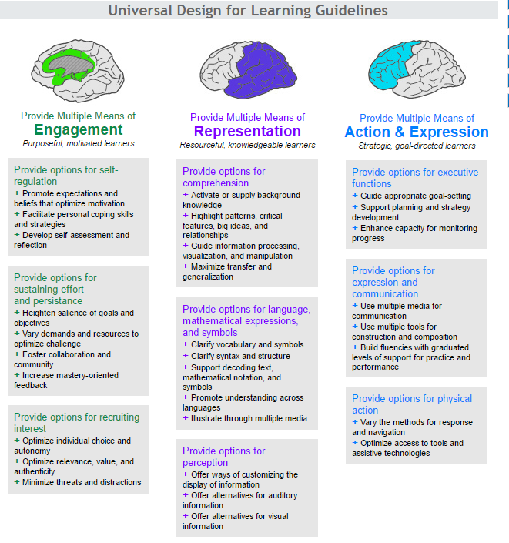

The second part of the Universal strategies relies on the teacher collaborating with the Program Planning Team to support specific programming.

Accessing Program Planning Team
At this point the teacher collaborates with the Program Planning Team

Seek additional data: Academic, social, and behavioral (formal/informal) assessments may be conducted to inform programming.

Create a Individual Program Plan (IPP) or Behavior Support Plan: A Student Support Plan, Individual Program Plan or Behavior Intervention Plan will be developed for students who require accommodations, modified curriculum programs and additional supports.

Implement, Monitor and Evaluate: Implement new programming information, monitor, evaluate and review progress at six week intervals. If interventions are not successful then advance to Tier 3 interventions.

Tier 2: Targeted Supports
- CORE Team: SLP/OT: Gr. 1-5
- Small group intervention
- Educational Assistant Support
- WRAP Team: Community Partners
- Student Support Facilitators
- Nursing
- English Language Learner Support
- Assistive Technology
- Family Wellness Worker

Tier 3: Intensive Supports
- Student Support Facilitators
- CORE Team: SLP/OT: Gr. 1-5
- RCSD Low Incidence Team Gr. ECS-12 (DHH. Audiology, Vision)
- Enhanced Team: OT, SLP, PT
- Nursing
- Medical/Emergency Plans
- Behaviour Support Plans
- Educational Assistants
- Psychologists
- Behaviour Consultant
- Assistive Technology
- Family Well Worker
- Truancy officer
- WRAP
- VTRA

Program Planning Team

Purpose

The Program Planning Team initiates conversation to support student progress. The team collaborates to review current programming and to provide access to school based resources. Additional supports, specialized services, and consultation may be accessed when reasonable attempts have been made to meet the needs of the learner.

Programming Team members may include the following:
- Administration
- Teachers
- Student Support Facilitator
- Family Wellness Worker
- Support Staff
- Students (optional)
- Parents (optional)

Referral Process
- Classroom teachers will implement universal strategies. complete essential background work (see Intervention Strategies Tier 1) with the student so when they seek additional school level supports the relevant information is collected and initial programming has occurred
- Classroom Teacher must contact parents/guardians prior to referral
- Classroom Teacher must complete a school based referral form and submit to the Student Support Facilitator
- Student Support Facilitator will organize and facilitate the PPT meeting.
- Student Support Facilitator will organize follow up meeting 6 weeks after the initial PPT to review progress
- Student Support Facilitator will ensure that minutes of each meeting have been recorded and shared with attendees.
- The principal ensures that regular Program Planning Team Meetings are scheduled within their school with the attendance of teachers, FWW, SSF and relevant staff

Examining a Collaborative Response Model: An example
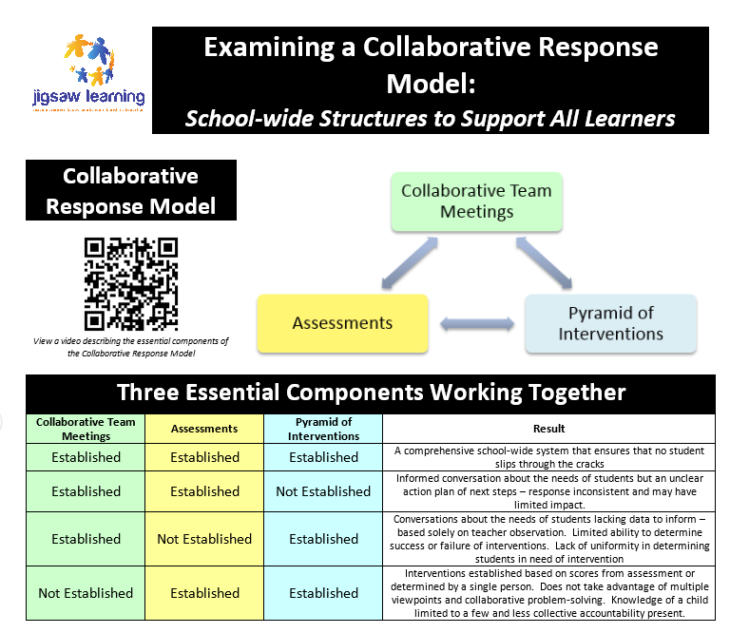
Wrap Around Support Team Collaboration

Purpose
​The Purpose of the Wrap Around Support Team is to draw upon the expertise in our community to support the needs of any student experiencing challenges. Prior to accessing the Wrap Around Support Team, schools will provide support at the school level, then the division level.

Wrap Around Support Team Collaboration may include the following:
- Parent/Guardian
- Mental Health
- Child and Family Service
- School Resource Officer (RCMP)
- WRSD Student Services Director or Coordinator
- School Administrator
- Student Support Facilitator
- Family Wellness Worker
- Others as needed

Referral Process
- ​​WrapAround Referral form is to be filled out by the school team (Student Support Facilitator, Administrator).
- Please send any Program Planning Team Meeting notes or other anecdotal records with the completed referral to the Student Services Administrative Specialist and Director of Student Services.
- Follow up with a phone call to Student Services Administrative Specialist to confirm request and possible meeting dates.​

Crisis Response/Threat and Risk Assessment

Purpose
The primary purpose of multidisciplinary Violence, Threat, Risk Assessment (VTRA) is to identify indicators that suggest a student may be moving on a pathway towards violence against him/herself or others and intervene to decrease that risk, prevent injury, and support the student in receiving the help necessary to address the issues contributing to the high-risk behaviour.

Violent Risk Threat Assessment Team Members will include the following:
- Parent/Guardian
- Mental Health
- Child and Family Service
- School Resource Officer (RCMP)
- WRSD Student Services Director or Coordinator
- School Administrator
- Student Support Facilitator
- Family Wellness Worker
- Others as needed

Referral Process
1. In the event of imminent danger - Call 911
2. Three VTRA trained staff will collect evidence, collaborate, and determine
whether a clear direct plausible threat exists. If so contact the Director of Wellness to enact the VTRA protocol.

GLOSSARY
To ensure common ground, the definitions of critical terms used in this manual are being placed at the front of the document.
In order to have a useful discussion on complex and challenging issues, all those involved in the discussion must agree on a common interpretation of words essential to discourse.
 | Accommodations or Adaptations | Accommodations are strategies that support students in achieving the learning outcomes of the provincial curriculum. Accommodations may include adjustments to assessment, instruction, environment or resources. Accommodations are sometimes referred to as Adaptations. These adaptations can include alternate formats (e.g., Braille, books-on-tape), instructional strategies (e.g., use of interpreters, visual cues and aids) and assessment procedures (e.g., oral exams, additional time).
 | Alternate School Program | The Alternate School Program is designed to address the student’s individual needs as necessitated by:  - A medical or mental health diagnosis  or  - Significant social, emotional, behavioural, legal or personal/environmental issues which have impacted their ability to engage successfully in the regular educational system
 | Assessment | Assessment is a systematic process for gathering information from many sources in order to make appropriate educational decisions for students. It is a progressive process identifying the student’s strengths and needs, and results in the design and implementation of selected educational strategies. Assessments are conducted on a continuum and include formal and informal assessments.
 | Diverse Learner | Diverse Learner are those characteristics which make it necessary to provide a student undertaking an educational program with resources different from those which are needed by most students. Diverse Learning needs are identified during an assessment of a student; they are the basis for determining an appropriate educational program (including necessary resources) for that student.
 | Inclusion | Inclusion is the value system that holds that all students are entitled to equitable access to learning, achievement and the pursuit of excellence in all aspects of their education. The practice of inclusion transcends the idea of physical location, and incorporates basic values that promote participation, friendship and interaction.
 | Individual Program Plans (IPPs) | Individual Program Plans (IPPs) are written records which document the individualized planning processes for students with special educational needs. Individualized planning is a continuous and integrated process of instruction, assessment, evaluation, decision-making and reporting.
 | Integration | Integration is one of the major strategies used to achieve an inclusive philosophy. Integration sees students with special needs included in educational settings with their peers who do not have special needs, and provided with the necessary accommodations and adaptations, determined on an individual basis, to enable them to be successful there. The principle of "placement in the most enabling learning environment" applies when decisions are made about the extent to which an individual student is placed in regular classrooms, or assigned to an alternate placement.
 | Interventions | In the field of special education, interventions are putting into practice plans, strategies and support to facilitate the learning and address the special needs of students.
 | Lead Team | A team that creates and implements a school vision that promotes and supports school improvement and student achievement. Members could include: Principal, Vice Principal, Student Support Facilitator, Family Wellness Worker, Teacher Representative.
 | Modifications | Modifications are changes to learning outcomes that result in students’ learning outcomes being substantially different from those of the provincial curriculum. Modifications are specifically selected to address a student’s special needs.
 | Modified Program | A modified program has learning outcomes that are substantially different from the prescribed curriculum, and specifically selected to meet the student's special needs. For example, a Grade 9 student in a modified math program could be focusing on functional computational skills in the context of handling money and personal budgeting. Or, in language arts, a Grade 5 student could be working on recognizing common signs and using the phone. In these examples the learning outcomes are substantially different from those of the curriculum for most other students. A student's program may include some courses that are modified and others that are adapted (see definition for adapted program above).
 | Parent | Parent (in the wording of the School Act) "...means, in respect of a student or of a child registered under section 13, a) the guardian of the person of the student or child; b) the person legally entitled to custody of the student or child; or c) the person who usually has the care and control of the student or child".
 | Parent/Guardian | According to Section 1 of the B.C. School Act, parent means “in respect of a student or of a child registered under Section 13, a) the guardian of the student or child, b) the person legally entitled to custody of the student or child, or c) the person who usually has the care and control of the student or child.”
 | Placement | Placement means the level, grade, classroom or educational setting that is most suitable for the student.
 | Program Planning Team | A Program Planning Team is an on-going team of school-based personnel which has a formal role to play as a problem-solving unit in assisting classroom teachers to develop and implement instructional and/or management strategies and to co-ordinate support resources for students with special needs within the school.
 | Students with special needs | Students with special needs are those who have disabilities of an intellectual, physical, sensory, emotional or behavioural nature, who have a learning disability or have exceptional gifts or talents.
 | Transition | Transition is the passage of students from one environment to another at key points in their development from childhood to adulthood, for example: into Kindergarten or from elementary school to middle or secondary; from home or pre-school to school; from class to class; from school to school; from school district to school district; and from school to postsecondary, community or work situations.
 | Transition planning | Transition planning is the preparation, planning and implementation required to enable students to make major transitions during their lives.

