Name: _________________________________________________
Grade: _________________________________________________
Identification : ___________________________________________
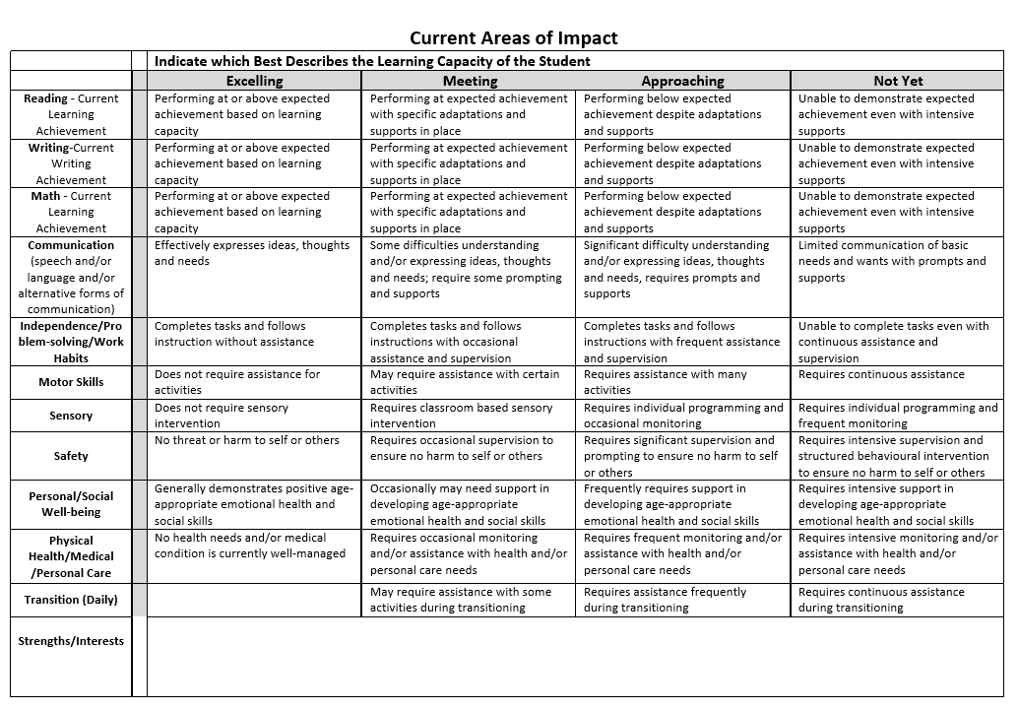
Description : _____________________________________________

