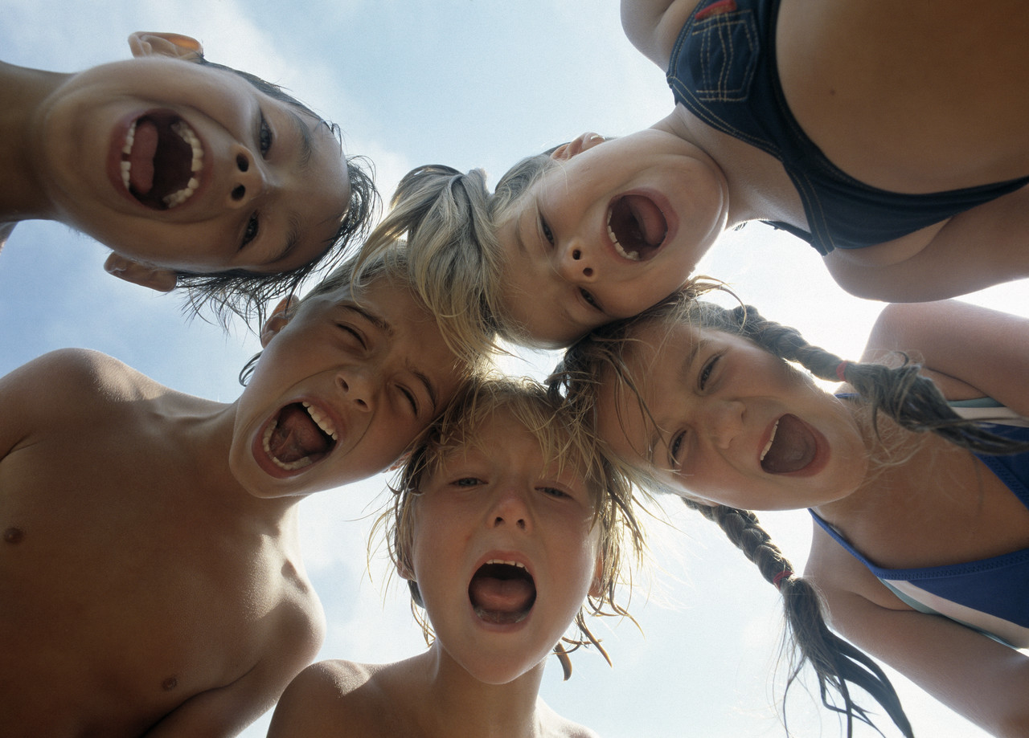
Think Social
2014
Be Social
The Red Deer Chapter of the Learning Disabilities Association of Alberta is accepting applications to our THINK SOCIAL program. The primary goal of the program is to assist students in acquiring social competencies that foster and enhance relationships. Students with learning disabilities (difficulties) and ADHD are presented with challenging hands-on activities, role playing experiences and games to facilitate skill acquisition. Pre-registration and payment required to be completed before February 18th for guaranteed acceptance into the program with only limited spots available for each date. Please call the office to make arrangements for enrollment at 403-340-3885.
Eight (8) Week Programs
Limited to ten (10) students per group.
Ages 7-10 years
Thursday Afternoon 3:30-5 PM
Dates: February 27- April 24
Location: Fairview School in collaboration with the Boys and Girls Club of Red Deer
Ages 10-13
Tuesday Evenings 5:30-7
Dates: February 25-April 22
Location: TBD

$250.00 +$30.00 LDAA membership
Limited Bursaries of $200 available for qualified applicants
Session 1: Being a Part of a Group – It’s About “Them” and “Me”
Session 2: Being Social with Our Body AND Mind
Session3: Being Social is Being Self Aware
Session 4: Being Social is Being an Empathic Observer
Session 5: Being Social is Adapting to Stress and Anxiety
Session 6: Being Social is Being a Partner in the Conversation
Session 7: Being Social is Managing Teasing and Bullying
Session 8: Being Social is Celebrating Our Gifts and Talents
Phone 403-340-3885
Email: Programs@LDreddeer.ca
Lower Level 3757 – 43 Avenue, Red Deer, AB
www.ldreddeer.ca

