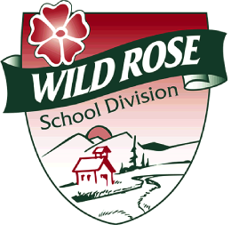 | A Authorization to Release Information  Wild Rose School Division

I, ________________________________________**, being the legal guardian of
Parent(s)/guardian

__________________________________ hereby grant permission for Wild Rose School
Child’s Name

Division personnel to release and/or receive information about:

my child _______________________________________
Name of Child

to: _______________________________________
Name of Individual

_______________________________________
Name of Agency and/or Individual

for the purpose of: __________________________________________________

___________________________________________________________________
.

Consent is valid from August to August, unless revoked in writing by the undersigned.

parent(s)/guardian |  | Date
parent(s)/guardian |  | Date

** The person signing this form and consenting to this service must be the legal guardian of
the child, as defined in the Family Law Act. In most cases, this will be the parent of the child,
but WRSD personnel will take reasonable stps to determine who the guardian(s) of the child is/are.

